Physics 30 Lesson 21 The Motor Effect

# Current carrying wires in external magnetic fields

In the previous lesson we learned that when a charged particle is injected into an external magnetic field, the charge experiences a force which is perpendicular to the particle’s line of motion. The same effect occurs when a current carrying wire is placed in an external magnetic field. The induced magnetic field around the current carrying wire interacts with the external magnetic field resulting in a force.

N

S

×

cross sectional view of a wire with conventional current flowing into the page

Fm

external magnetic field

To find the direction of the force between a current carrying wire and an external field, we use the 3rd hand rule that we learned about in Lesson 20:

thumb (left)

fingers

palm

(Into the page)

1. The fingers point in the direction of the external magnetic field (B).
2. The thumb points in the direction of the current (right hand) or electron flow (left hand).
3. The palm indicates the direction of the force on the wire (F).

For the diagram below, what is the direction of the deflecting force if the electron flow is into the page?

N

S

x

Using the left hand (negative charge), the fingers (B) point to the right and the thumb (Ie-) points into the page – the palm indicates a force **up the page**.

For the diagram below, electrons are flowing from A to B in the conductor. Predict the direction of movement of the wire.

S

N

A

B

e-

Using the left hand (negative charge), the fingers (B) point to the left and the thumb (e- flow) points down the page – the palm indicates a force which is **out of the page**.

The conductor is forced up out of the page by the magnetic field. Which direction is the current flowing?

S

N

A

B

If a question uses the term current alone, assume that it is referring to conventional current (right hand). The fingers (B) point to the left and the palm faces you. The thumb naturally points up the page – **the current is flowing from B to A**.

# Magnitude of the deflecting force on a conductor

To derive the magnetic force equation for a conductor, we shall use the diagram on the right.

S

N

L

From Lesson 20 we know that the deflecting force on a charged particle moving through an external magnetic field is calculated using:



Speed equals distance divided by time and from the diagram d = L



Substituting this into our force equation we get



But we also know from Lesson 18 that . Substituting I for  we get



where

Fm deflecting force (N)

B magnetic field strength (T)

I current (A)

L length of wire within the magnetic field (m)

❑ angle between I and B

The maximum deflecting force will occur when  = 90o.



Refer to Pearson pages 603 to 605 for a discussion about the motor effect.

In the diagram below, a 5.0 cm wire experiences a 0.023 N force up out of the page in a 1.25 T magnetic field. What is the magnitude and direction of the current in the conductor?

The right hand rule tells us that the current is flowing to the right.

(Since no angle is given, we assume 90o)

S

N



A 25 cm wire is placed in a magnetic field at an angle of 30o. What is the magnetic field strength if a 0.75 A current produces a 2.6 N force?



# The current balance

A *current balance* is an instrument used to demonstrate the deflecting force of a current carrying wire in an external magnetic field. The current balance is constructed of a small rectangular piece of wood with a piece of wire around half of the perimeter of the wood (WXYZ in the diagram below). The ends of the wire are bent so that they act as a fulcrum for the balance. The external magnetic field is supplied by a solenoid which has a completely separate current. The magnetic field acts directly down the middle of the solenoid.

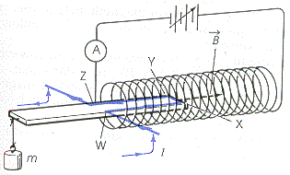

Known masses are attached to the one end of the balance. Current is applied through the wire conductor until the downward force of gravity on the mass is countered equally by the downward force acting on the conductor inside the solenoid.

m

wire in magnetic field

Fm

Fg

Fg = Fm

In looking at the sections of wire inside the solenoid, which section(s) will provide a deflecting force Fm? Remember, only the sections of wire perpendicular to the field will produce a magnetic force. Since sections WX and YZ are parallel to the magnetic field, they do nothing. Only section XY provides the length (L) to produce the magnetic force.

*Example 6*

A solenoid lies horizontally with a current balance WXYZ balanced in the solenoid core. (See diagram above.) Sides WX and YZ are 7.10 cm long and side XY is 1.90 cm long. A current of 0.500 A flows through conductor WXYZ and a mass of 25 g is necessary to balance the current balance. What is the magnetic field strength in the solenoid?

L = 0.0190 m (ignore the other sides)



# Electric motors

After Oersted’s discovery, Andre-Marie Ampere performed extensive experiments and did an insightful mathematical analysis of the magnetic field induced around a current carrying wire. In addition, he studied the forces between current carrying wires. The induced magnetic fields around the wires interacted to produce a repulsive or an attractive force depending on the relative directions of the currents – if the currents were in the same direction the wires attracted each other. In fact, the unit for current (ampere) is defined as the current required in each of two current carrying wires, 1 m long and separated 1 m in air to produce a force of 2.00 x 10-7 N. (Refer to Pearson page 607 for a discussion about Ampere’s work.) After Ampere’s work was published, Michael Faraday quickly began to study the forces described by Ampere. In 1821, Faraday developed the **electromagnetic rotator**, which would later be known as the first **electric motor**.

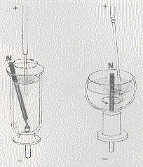

Faraday designed two versions of his rotator. In the first version, a bar magnet revolves around the circular lines of magnetic force surrounding a fixed current. In the second version, the rod carrying the current revolves around a fixed bar magnet. In both cases the container holds mercury which is a liquid at room temperature. In this way, large amounts of current can be passed from the base to the overhead support. In the years that followed, the **basic electric motor design** was improved to allow the efficient **conversion of electric energy into mechanical energy**.

# Practice problems

1. Current is flowing from A to B. Predict the direction of movement of the conductor.

S

N

A

B

2. Current through the conductor results in a force to the right. Which way is conventional current flowing?

N

S

F

3. In the diagram below, a 10 cm wire carries a current of 20 A through a magnetic field of 2.0 T. What is the deflecting force on the conductor? (4.0 N into page)

S

N

I

4. A 40 cm conductor cuts through a magnetic field of 0.50 T at an angle of 60o to the field. If the wire carries a current of 20 A, what is the deflecting force on the conductor? (3.5 N)

# Hand-in assignment

1. What is the direction of the deflecting force on a stream of alpha particles moving away from you across a magnetic field whose direction is down?

2. If you wanted to write units for magnetic flux density into an equation and were limited to the following units: metre, kilogram, second, ampere, what units would you use?

3. A single conductor in a power transmission line is 40 m long and carries a current of 80 A from east to west. It lies perpendicularly across the Earth’s magnetic field somewhere in Canada. If the Earth’s magnetic flux density is 2.0 x 10-7 T, what is the magnitude and direction of the deflecting force on the transmission line?

(6.4 x 10-4 N down)

4. A conductor which is 30 cm long with a mass of 20 g is suspended horizontally in a magnetic field whose magnetic flux density is 0.12 T. What current is required in order that the magnetic force balances the gravitational force? (5.5 A)

5. If a 45 mg conductor that is 15 cm long is accelerating upward (against gravity) at 4.19 m/s2 in a 5.0 mT field, how much current must be flowing in the conductor? (0.84 A)

6. In the following diagram, if the conductor is forced out of the page by the motor effect, what direction does the current flow in the conductor?

N

S

7. A solenoid lies horizontally with a current balance WXYZ balanced in the solenoid core as shown in the diagram.

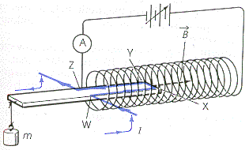

Sides WX and ZY are 7.10 cm long and side XY is 1.90 cm. A current of 6.0 A flows through the conductor of the current balance. If a 17.6 g mass is necessary to balance the current balance, what is the magnetic field strength of the solenoid? (1.51 T)

8. A coil 15 cm long with 100 turns lies in a horizontal plane. with a light frame supporting conducting wire WXYZ balanced horizontally at its midpoint in the core of the coil, as shown in the diagram below:

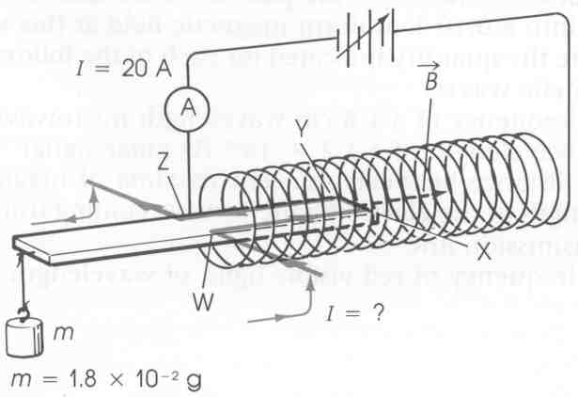

Sides WX and YZ of the conductor are 5.0 cm long, and are parallel to the axis of the coil, whereas side XY is 1.5 cm long and perpendicular to the axis of the coil. The current flowing through the conductor is 20 A. What current must flow through the conductor WXYZ in order to keep in horizontal balance, when a mass of 1.8 x 10-2 g hangs from the far end of the light frame that holds the conductor? Use the following formula:

 Where:

o = 4 x 10-7 

B – magnetic field strength (T)

N – number of turns of wire

I – current through the coil (A)

L – length of coil (m)

9. A 20 cm long wire carries a current of 1.0 A in a 0.020 T field. Another wire which is 10 cm long carries a current of 3.0 A in the same field. State the ratio of the deflecting force in case two to the deflecting force in case one. (1.5 to 1)

10. A 12 cm long wire hangs perpendicularly across a magnetic field whose density is 0.015 T. How great must the current be to produce a motor effect of 1.0 mN?

(5.6 x 10-1 A)

11. The following data was collected for alpha particles entering a magnetic field.

magnetic force (x 10-19 N) speed (x 105 m/s)­­­­

1.6 1.0

3.2 2.0

4.8 3.0

6.4 4.0

8.0 5.0

Using a graphing technique, what is the magnetic field strength? (5.0 x 10-6 T)